* **Names and IDs:**
* Badr Elsayed - **22010664**
* Adham Anas - **22010601**
* Nour Khaled - **22011319**
* Ali El-Deen Maher - **22010934**
* **Steps required to run code:**
  1. Backend:
* Open the EMail_Backend folder using IntelliJ IDE or any other IDE, run the EmailApplication.java class.
  1. Frontend:
* Open the paint-frontend folder using visual studio IDE, then open the terminal of the IDE, and write npm install in the terminal.
* Then write “npm run dev” in the terminal to open the project, on port “http://localhost:5173/”
  1. Then you can use the Email application.
* 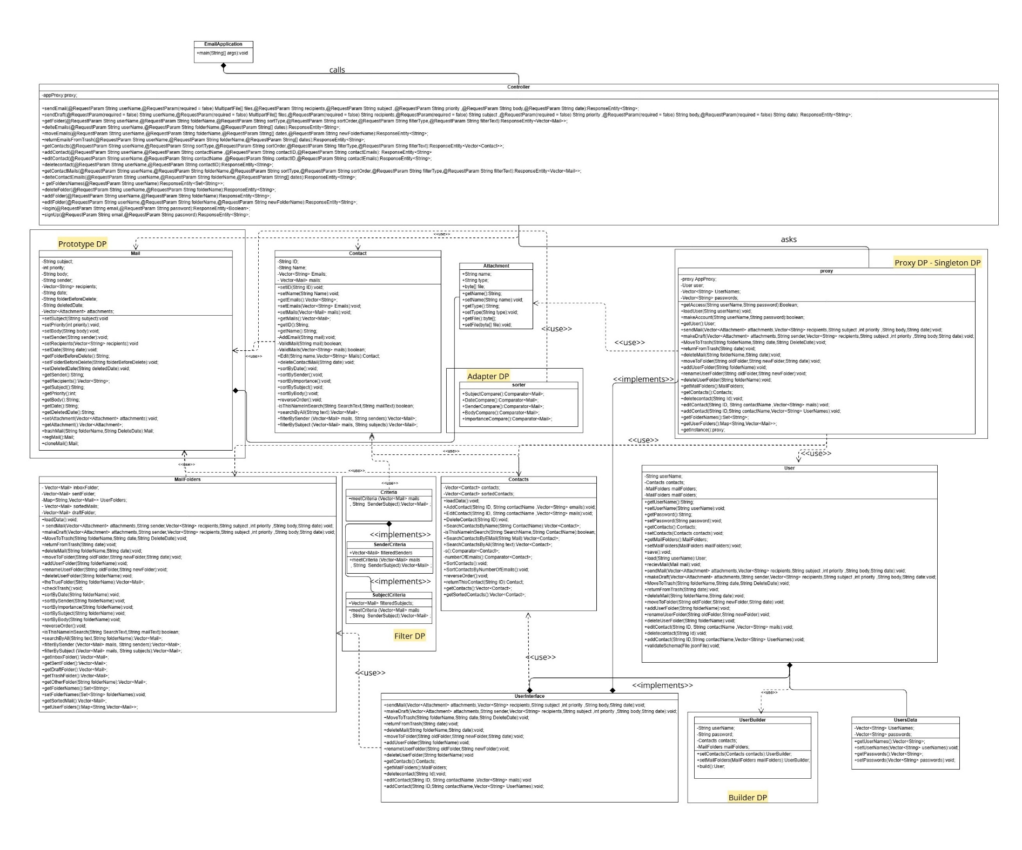**UML diagram:**
* **Design Patterns:**

1. Singleton design pattern

* We used this design pattern to create large classes that only require a single instance, which is then used repeatedly, to conserve memory and facilitate reusability.

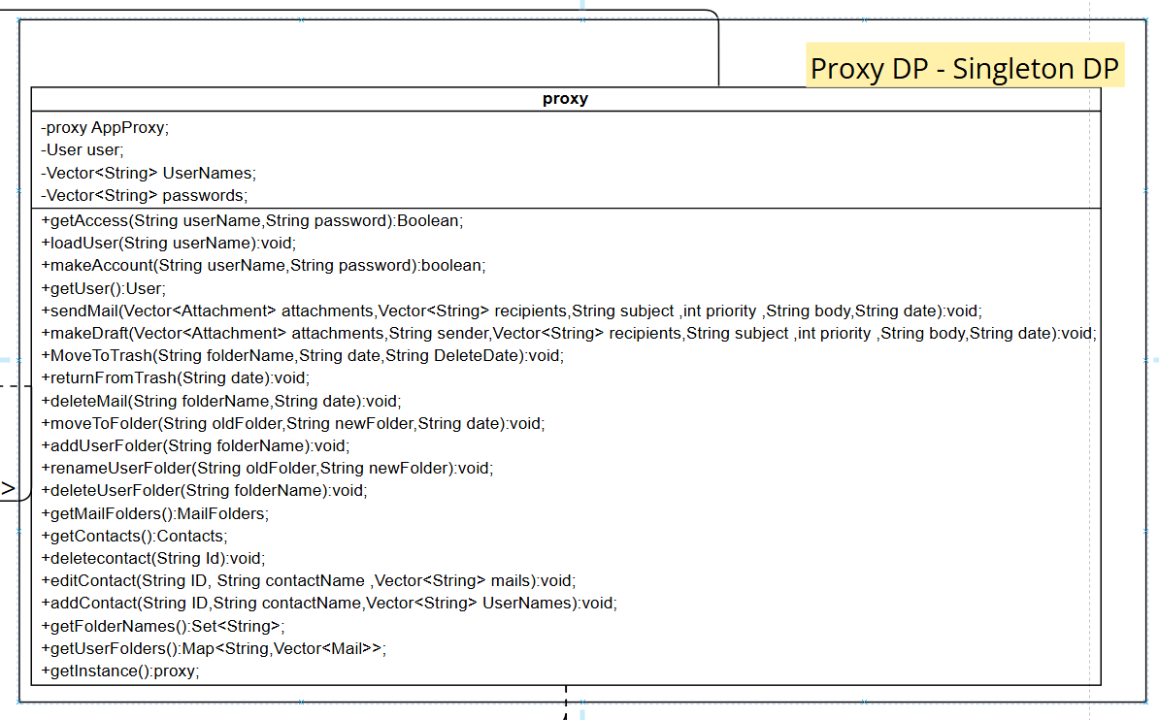

1. Adapter design pattern

* We used this design pattern to sort emails based on the user's selected criteria and retrieve all emails in the specified order.

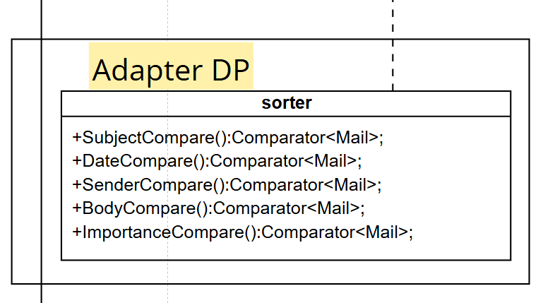

1. Filter design pattern

* This design pattern was used to help us in filtering emails that fit the user's selected criteria and retrieving all emails that had or shared the same attributes as the user input.

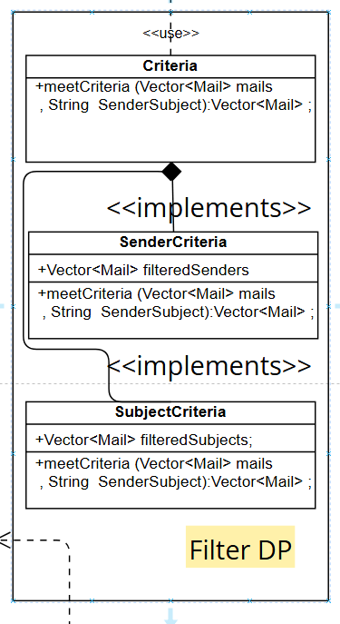

1. Builder design pattern

* We have built all the user profile attributes, including the username, password, default folders, and so on, using the builder design pattern to separate the user from the complicated process of creating a profile.

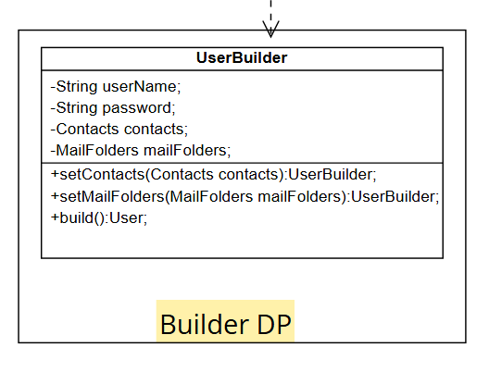

1. Proxy design pattern

* We used this design pattern to stop anyone from accessing the system unless they are already logged in.



1. Prototype design pattern

* This design pattern facilitates the creation of mail object clones so that each can be modified before being saved to a database (for example, a message with several recipients should only appear to one recipient with only his name as recipient).

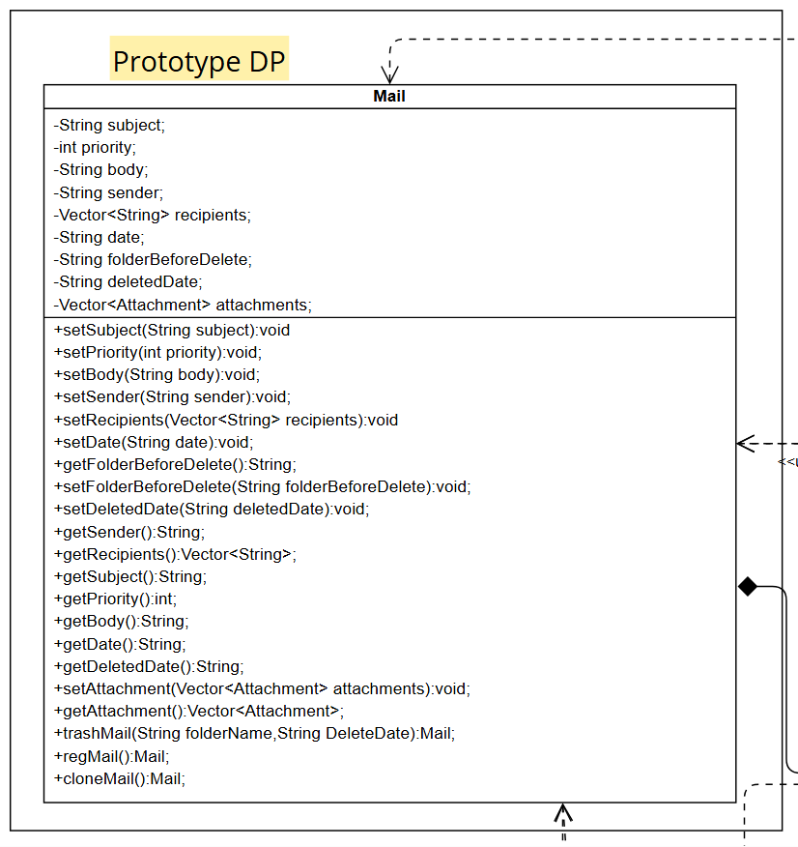

* **Snapshots UI and User guide:**

1. Login page:

Enter Email and Password.

If you don’t have an account, you can sign up!

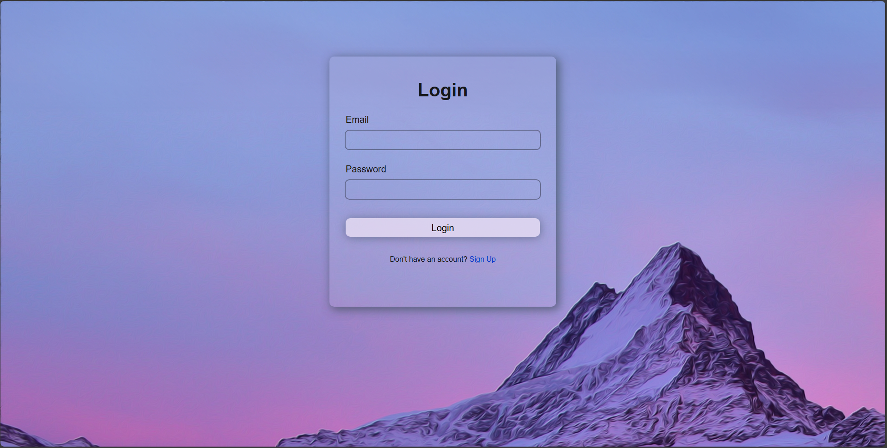

1. Sign Up page:

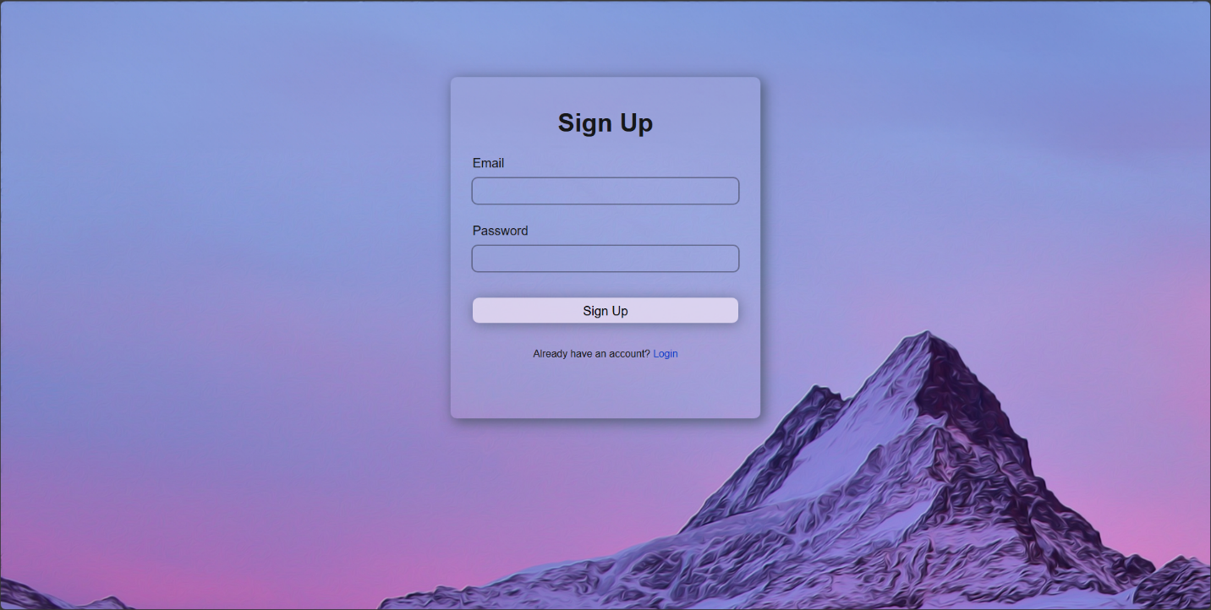Enter Email and Password to sign up.

1. 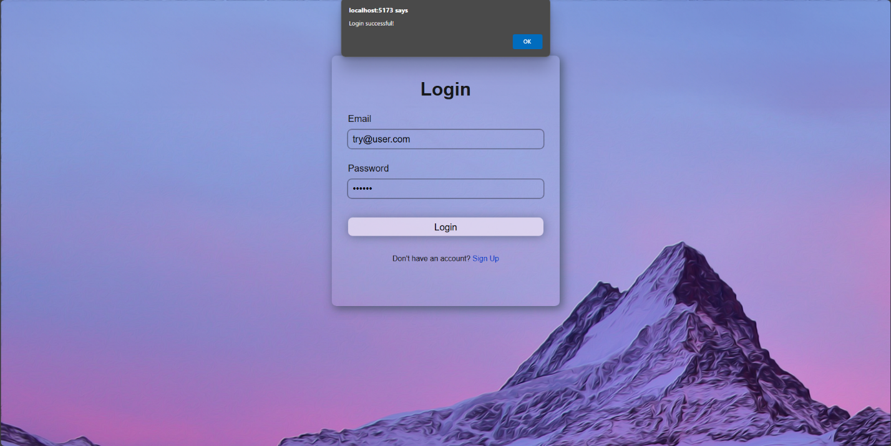Login Successful!
2. 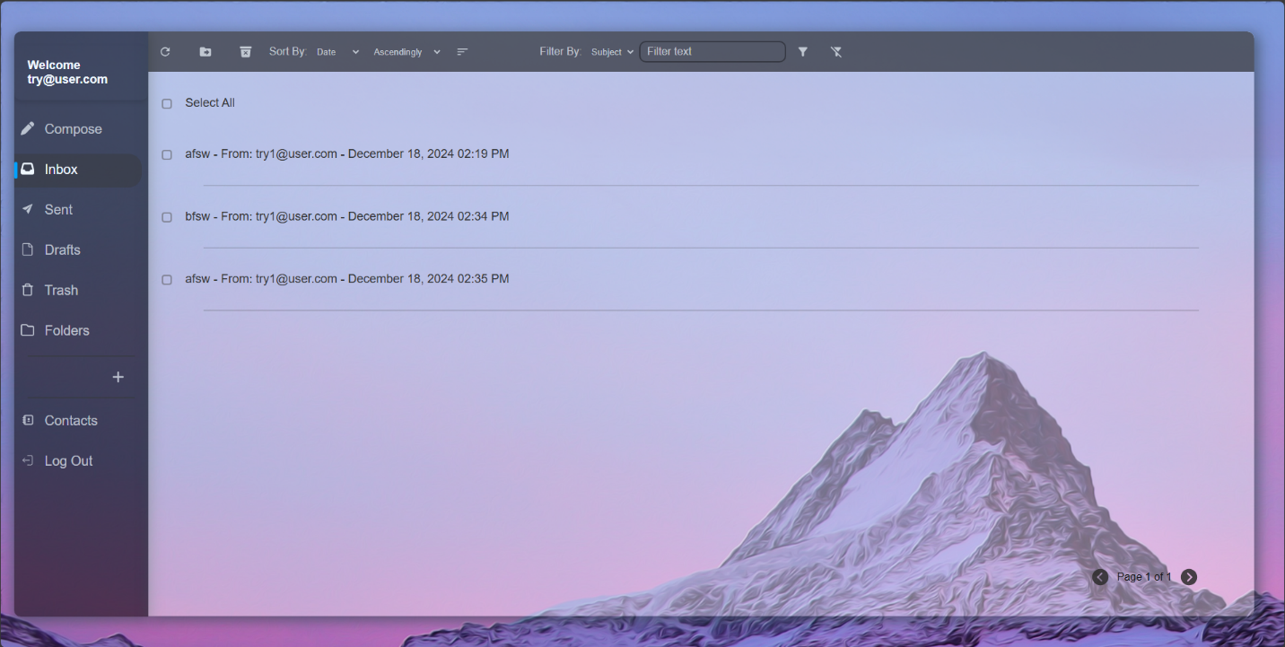Sidebar
3. Toolbar

Refresh your folder.

Move / delete selected Emails.

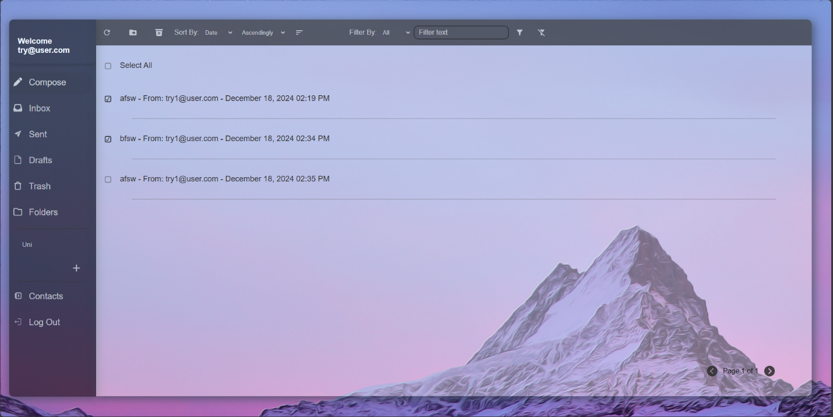

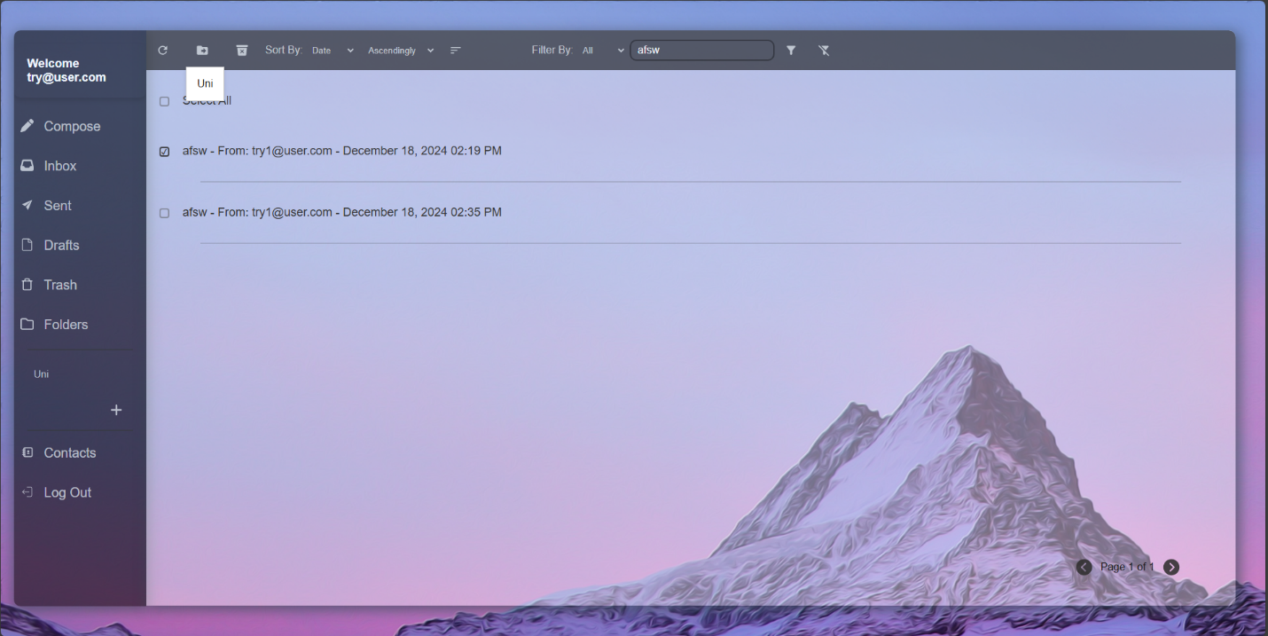

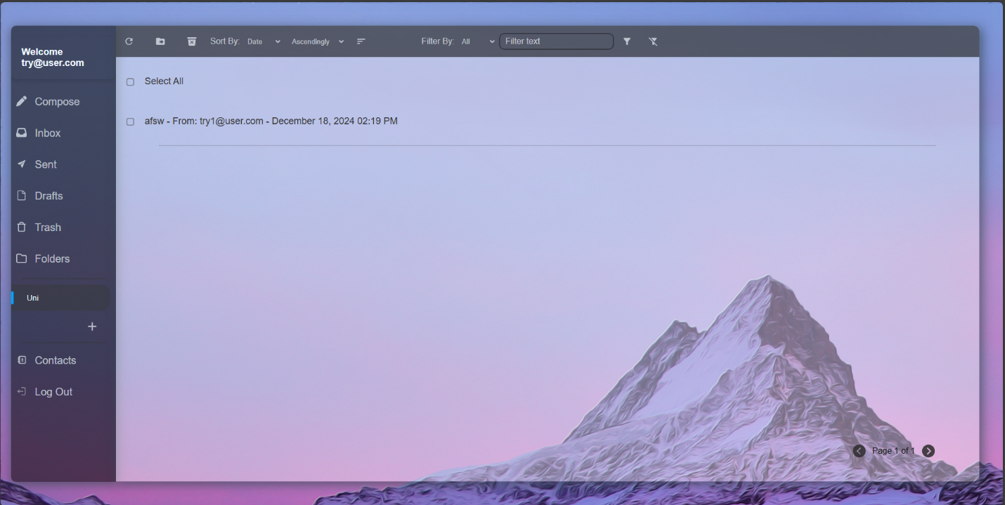

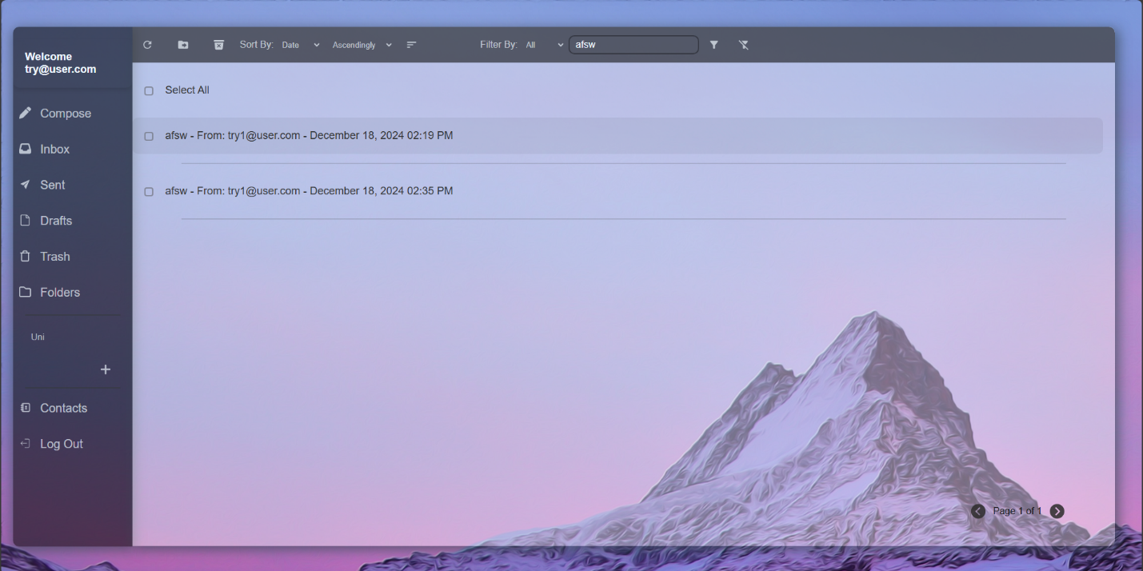Filter and sort your emails.

Clear filter when done.



1. 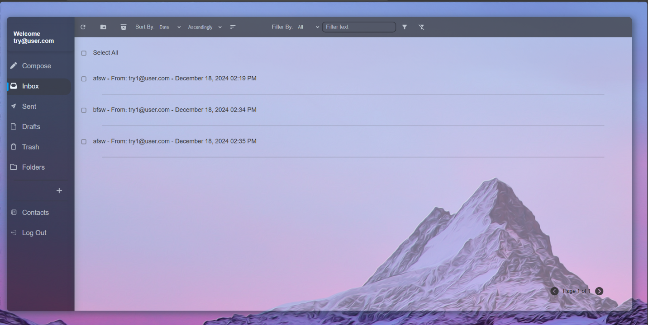Inbox
2. Compose

Write your email here, setting its priority and adding attachments to it too.

Not ready to send it yet? Move it to your drafts to send it later.

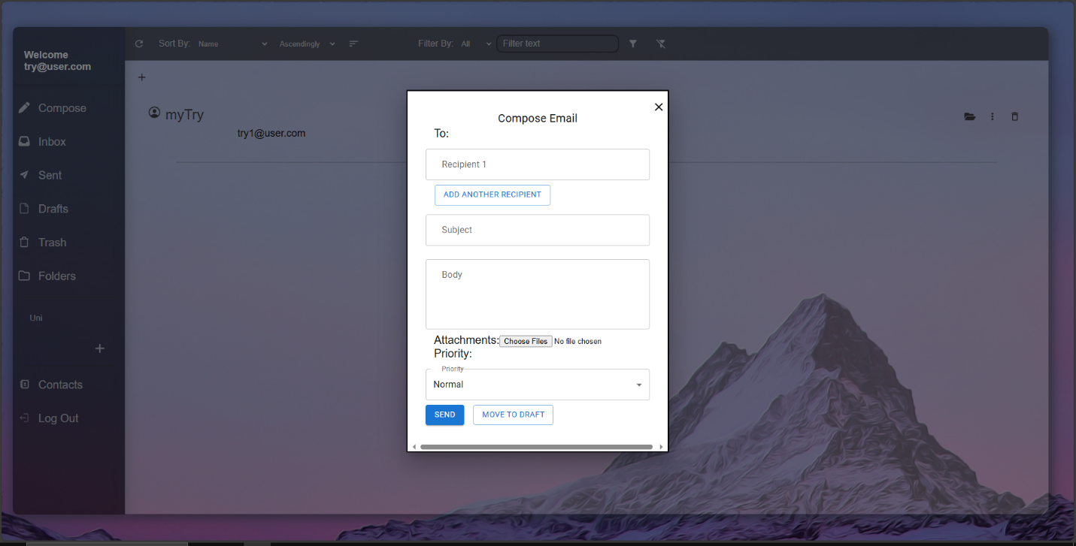

1. Sent folder

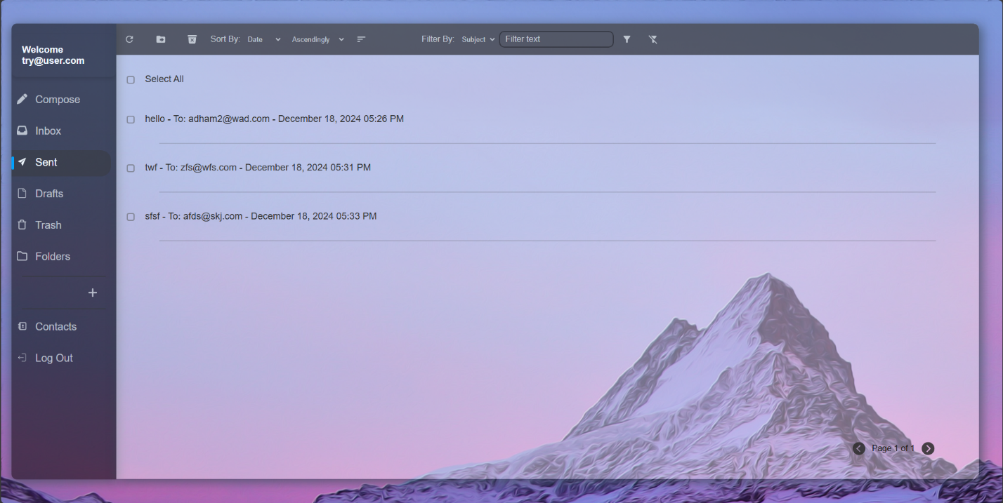Trash and drafts too.

1. Folders

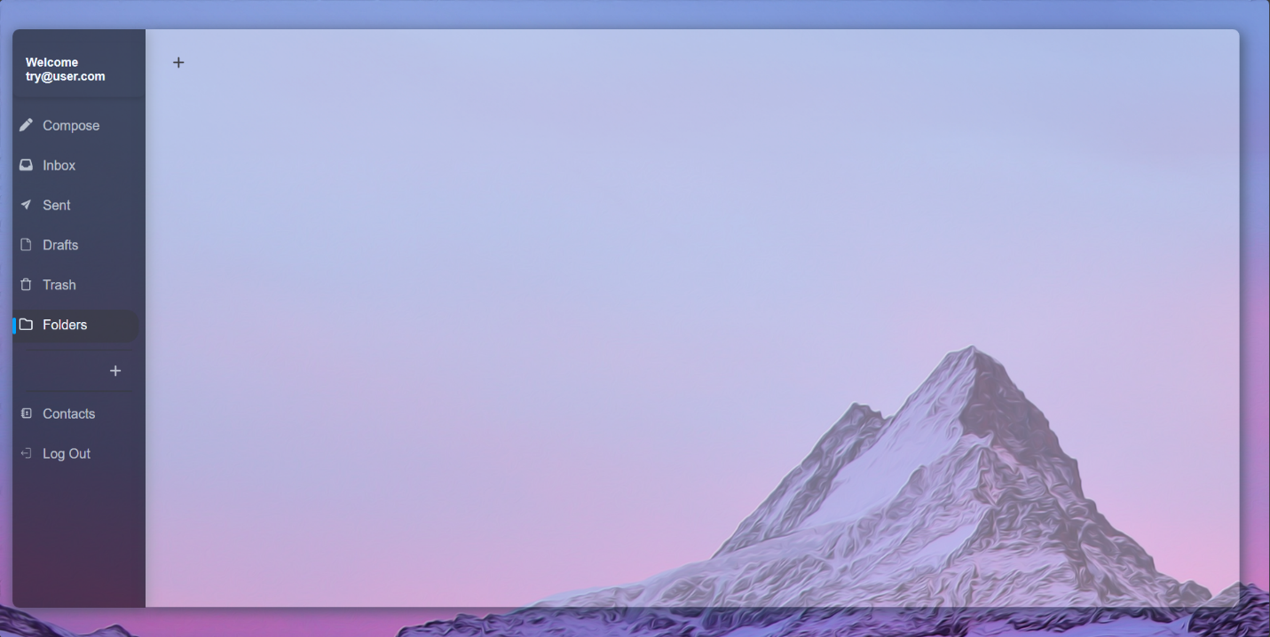You can add custom folders too!

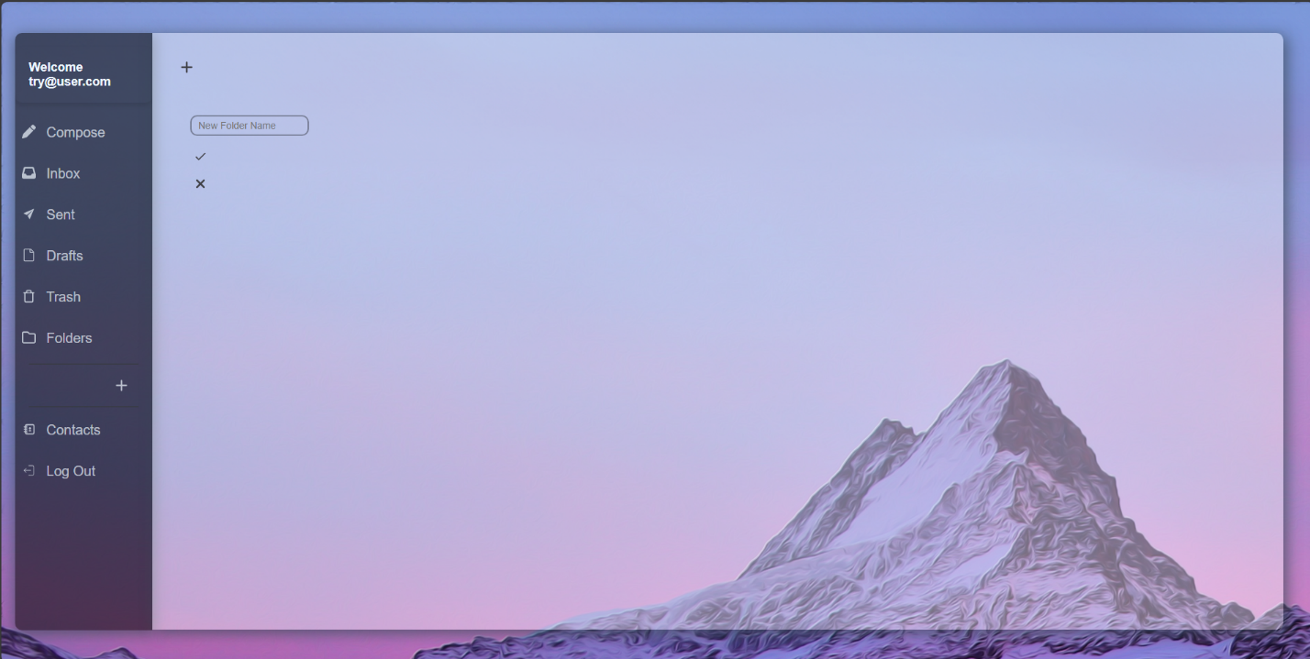

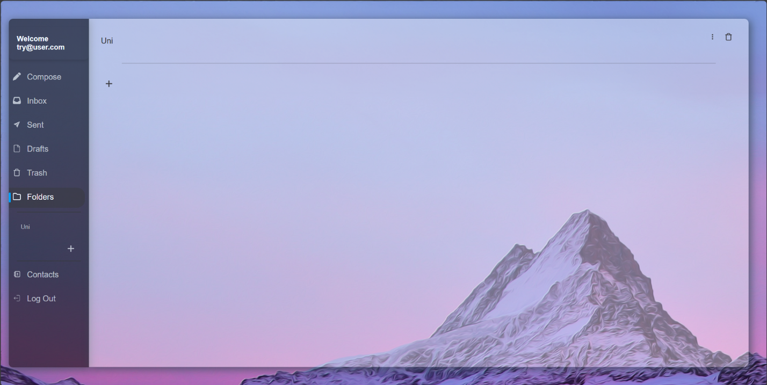

You can rename your folders or delete them.

1. Contacts

View and 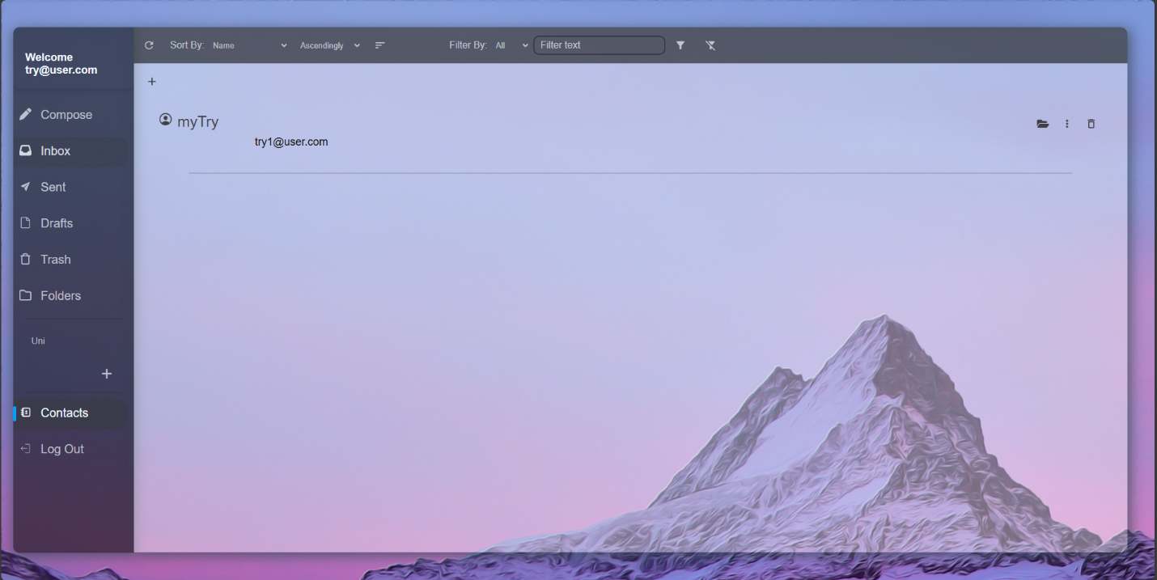Add to your contacts here.

Rename, delete and view all emails from this specific contact!

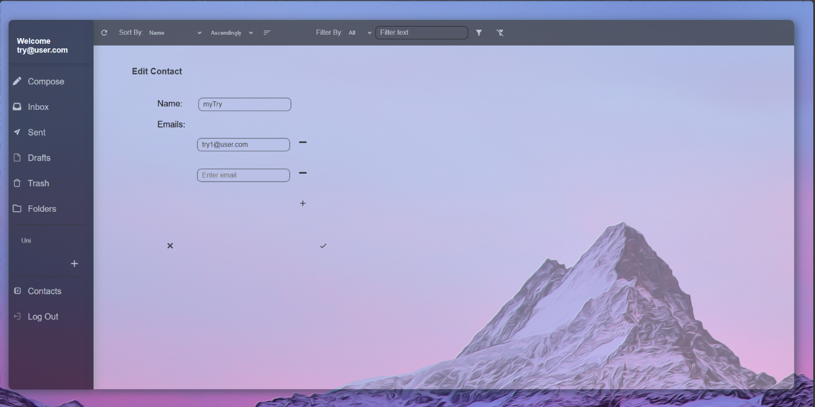Add more emails to your contact.

1. Log out when you’re done.